Transformation and Innovation Exchange

**Transformation and Innovation Exchange Self-Assessment – Benchmarking Window**

Date here

The [Transformation and Innovation Exchange](https://www.local.gov.uk/our-support/transformation/transformation-innovation-exchange-tiex?utm_medium=email&utm_source=govdelivery) (TIEx) [self-assessment tool](https://www.local.gov.uk/our-support/transformation/transformation-innovation-exchange-tiex?utm_medium=email&utm_source=govdelivery) provides a comprehensive overview of your organisation's performance across the characteristics of a high functioning local authority, identifying areas to focus and to prioritise, backed up by an extensive library of tailored resources to support you at every stage of you transformation journey.

The LGA will undertake periodic benchmarking exercises, which will be publicised in advance to existing users as well as to encourage uptake from others. Users will be able to compare their results with the anonymised results of other local authorities sharing the same geographical and council type characteristics to help councils gauge where they are on their transformation journeys in relation to others.

**The Process**

During benchmarking periods councils who have previously made multiple submissions will be contacted to provide a definitive council-wide submission for comparative purposes. All other submissions will be viewable to those within the council, but the published submission will act as the council’s official position, for the purposes of the benchmarking exercise.

For those councils with only one submission this will be taken as the council position for the purposes of benchmarking, but that user will be contacted prior to the period closing to confirm you are happy for it to be included.

For those councils who are yet to publish a submission we ask that for the purposes of this exercise you identify and agree a single person to complete the assessment on behalf of your council. This can be done collaboratively between a group of you or by one nominated ‘responsible officer’.

Changes and other back-end functions can be carried out by members of the [LGA Transformation team](mailto:transformation@local.gov.uk) upon request during the window.

After the benchmarking window closes councils will be able to compare themselves against a series of comparators as well as allowing you to establish a baseline in which you can compare your performance in the future.

The LGA intends to set up benchmarking windows on a periodic basis, the regularity of which will be determined on usage and demand.

To complement the process and get you connected with other councils facing similar challenges to yourselves we will be setting up a new **TIEx Teams channel** for all of you who have opted in to be connected to others. The channel will provide all the latest transformation offers from the team, updates and opportunities for you to share concerns, queries and advice between you.

**Why should we benchmark?**

Some of the benefits of benchmarking include:

* Driving meaningful change: benchmarking provides a clear, data-driven picture of where your council stands, enabling you to make informed decisions and drive impactful transformation.
* Comparing performance: compare your council’s performance with others in your region and with councils similar to yourselves for more relevant and meaningful analysis.

* Identifying and sharing good practice: discover and adopt successful strategies from councils on similar journeys to yourself to enhance your own transformation efforts.
* Objective self-assessment: gain an unbiased perspective on your council’s transformation progress, helping to highlight strengths and pinpoint areas for improvement.
* Evidence-based reporting: use benchmarking data to support your reports and presentations with robust, comparative evidence, reinforcing your council’s strategic decisions.
* Collaborative learning: engage in our new **TIEx Team channel** where councils can share insights and learn from each other’s experiences, fostering a collaborative approach to transformation.
* Tracking progress over time: establish a baseline that can be revisited in future assessments to track your council’s progress and measure the impact of implemented changes.
* Boost accountability: encourage transparency and accountability within your council by measuring performance against peers and setting clear, achievable goals.

**Comparing your Performance**

In order to analyse your performance and compare this with other councils across the country with similar characteristics please follow these basic instructions:

* Log in and click onto the ‘Results’ tab which will be showing your dashboard of responses.
* You can navigate and scroll through the ‘Critical Success Factors’ and ‘Characteristics’ on the lefthand task bar for a visual comparison.
* The dashboard shows your results with an option on the righthand side to toggle comparators – for example to compare yourself against ‘All English Authorities’
* Click through the list to select the relevant comparator you wish to compare yourself with.

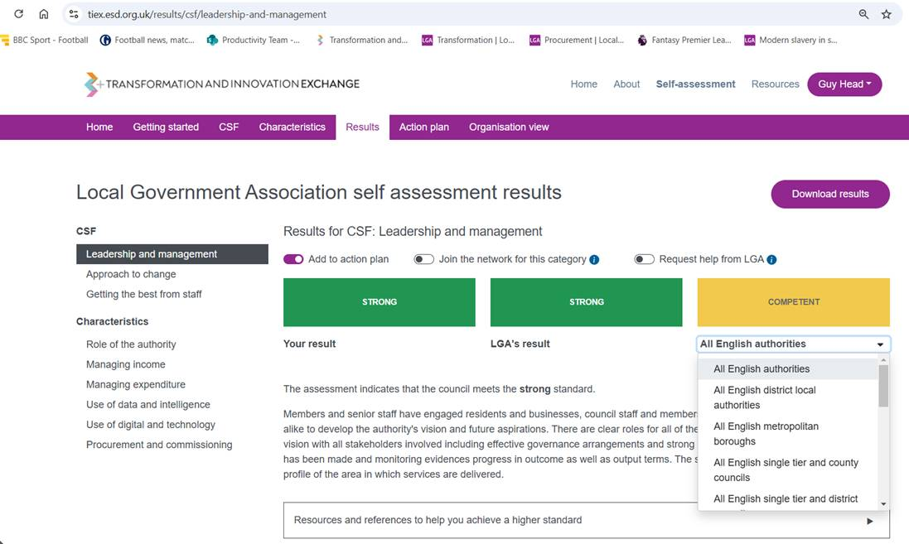

* To create a report – click ‘Download results’ and it will create a full downloadable report with your current performance compared with your chosen comparator.

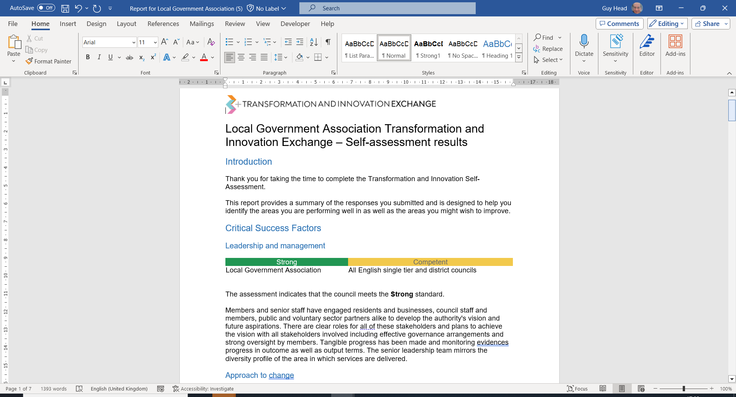

**Feedback**

As part of the LGA’s commitment to continuously improve our support offer and to get a sense check of the tools and services we provide please let us know if there is anything we can improve to make this exercise better, any feedback on the information provided, the process, the Comms and the outputs is appreciated and will help us improve.

Please complete the [feedback form](https://research.local.gov.uk/jfe/form/SV_0P5BLwj9Qx7znhQ) and feel free to contact us with any queries or issues you might encounter during this period at [Transformation@local.gov.uk](mailto:Transformation@local.gov.uk).